7.2.3.5 Packet Tracer – Troubleshooting EIGRP for IPv4
Addressing Table
Device | Interface | IP Address | Subnet Mask | Default Gateway
R1 | G0/0 | 172.31.10.1 | 255.255.255.0 | N/A
 | S0/0/0 | 172.31.40.225 | 255.255.255.252 | N/A
 | S0/0/1 | 172.31.40.233 | 255.255.255.252 | N/A
R2 | G0/0 | 172.31.20.1 | 255.255.255.0 | N/A
 | S0/0/0 | 172.31.40.226 | 255.255.255.252 | N/A
 | S0/0/1 | 172.31.40.229 | 255.255.255.252 | N/A
 | S0/1/0 | 209.165.201.1 | 255.255.255.224 | N/A
R3 | G0/0 | 172.31.30.1 | 255.255.255.0 | N/A
 | S0/0/0 | 172.31.40.234 | 255.255.255.252 | N/A
 | S0/0/1 | 172.31.40.230 | 255.255.255.252 | N/A
PC1 | NIC | 172.31.10.10 | 255.255.255.0 | 172.31.10.1
PC2 | NIC | 172.31.20.10 | 255.255.255.0 | 172.31.20.1
PC3 | NIC | 172.31.30.10 | 255.255.255.0 | 172.31.30.1

Scenario
In this activity, you will troubleshoot EIGRP neighbor issues. Use show commands to identify errors in the network configuration. Then, you will document the errors you discover and implement an appropriate solution. Finally, you will verify full end-to-end connectivity is restored.

Troubleshooting Process
- Use testing commands to discover connectivity problems in the network and document the problem in the Documentation Table.

- Use verification commands to discover the source of the problem and devise an appropriate solution to implement. Document the proposed solution in the Documentation Table.

- Implement each solution one at a time and verify if the problem is resolved. Indicate the resolution status in the Documentation Table.

- If the problem is not resolved, it may be necessary to first remove the implemented solution before returning to Step 2.

- Once all identified problems are resolved, test for full end-to-end connectivity.

R1 | 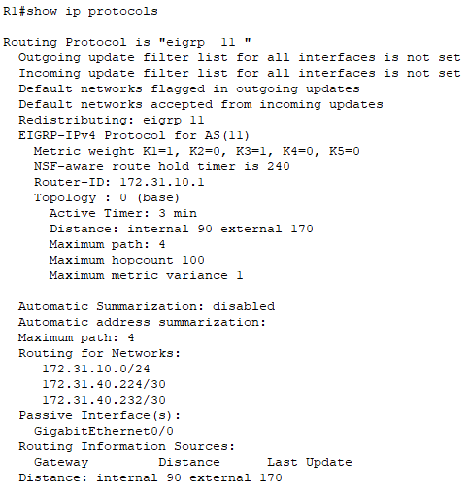  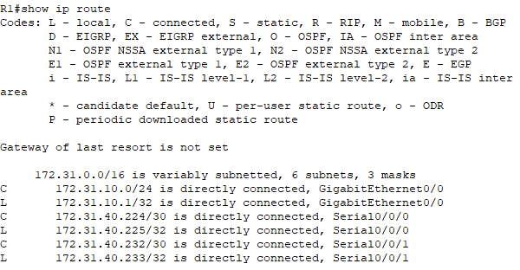
R2 | 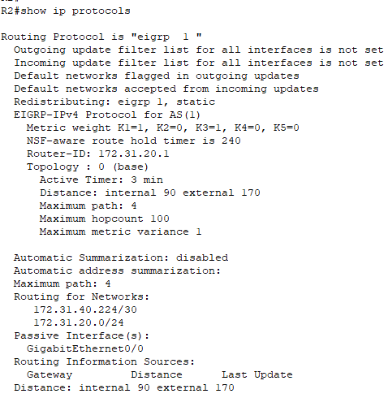  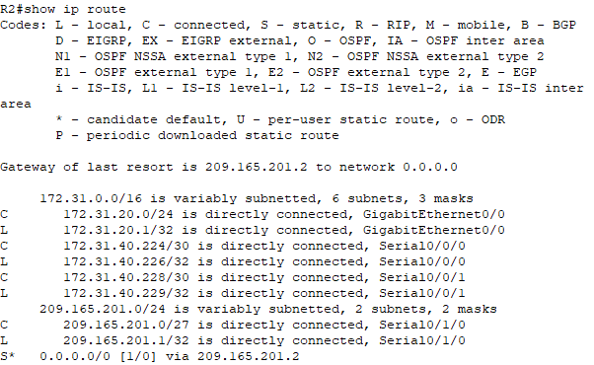
R3 | 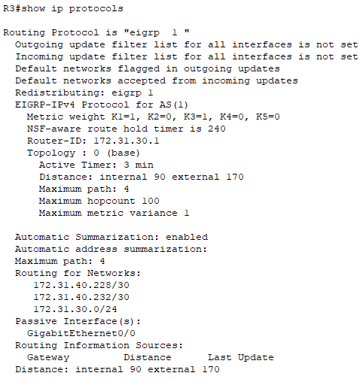  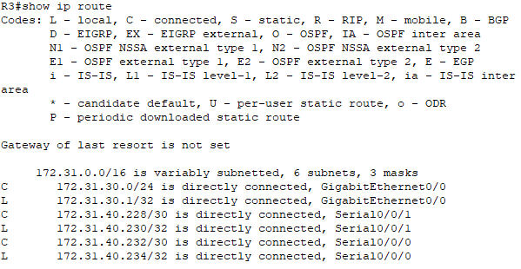

Documentation Table
Device | Identified Problem | Proposed Solution | Resolved?
R1 | No adjacencies established | 1) Remove EIGRP 11  2) Configure EIGRP 1  3) Advertising directly connected to the network  4) Set passive interface  5) Disable automatic summarization | Slove
R2 | Does not form adjacency with R3 | Advertise the 172.31.40.288/30 network | Slove
R3 | Perform automatic summarization | Disable auto-summary with the no auto-summary command | Slove

R1 | 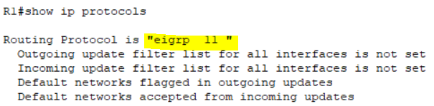  Should be EIGRP 1  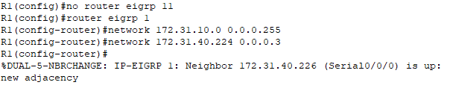  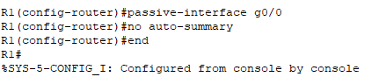  R1(config)#no router eigrp 11  R1(config)#router eigrp 1  R1(config-router)#network 172.31.10.0 0.0.0.255  R1(config-router)#network 172.31.40.224 0.0.0.3  R1(config-router)#network 172.31.40.232 0.0.0.3  R1(config-router)#passive-interface g0/0  R1(config-router)#no auto-summary
R2 | 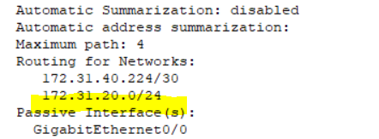  Missing 172.31.40.288/30  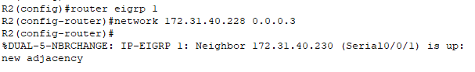  R2(config)#router eigrp 1  R2(config-router)#network 172.31.40.228 0.0.0.3
R3 | 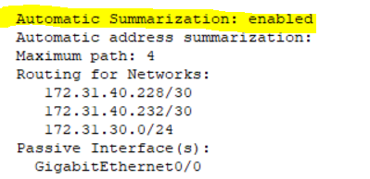  The automatic summarization should be disable  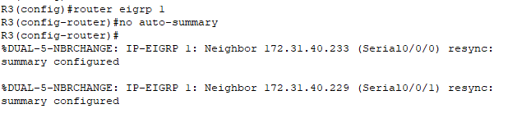  R3(config)#router eigrp 1  R3(config-router)#no auto-summary

